Assignment 4

Submitted by: Weerdhawal Chowgule

Goal:

In this assignment we have to match faces from the given data set on the basis of Eigen-Face approach.The training data set provided contains 33 different persons and each individual data set has a set of images of the person with different orientations, distortions etc. We also have to find how many images match , also we have to use different colorspaces and different K values.

Explanation of Algorithm and Program Flow:

1. The first step is the training phase in which we import all the images and then train them in which colorspace we require and make a vector Im of all the images.
2. In the second step we calculate the mean value (Mue) of all the IM images.
3. In this step we subtract the Mue value from the Im values and assign the new Im vector value to a matrix A.
4. Next perform Eigen decomposition on A and calculate matrix X and lambda.
5. From this X matrix select the largest K values, to do this in matlab use the values form last as in matlab they are stored in ascending order hence we can get better precision.
6. Next we multiply the selected largest K values stored in X matrix with A .
7. Next we calculate the alpha Matrix.
8. From here the testing phase begins:
   1. First we take the images from the testing folder and convert it into a vector IMtest.
   2. Next we subtract the Mue value from the IMtext Matrix and perform alpha test.
   3. Next here we use different Norms as specified in the problem definition(Norm 1 and Norm 2)
9. Final step we calculate the Accuracy , and display the most closest images.

**Results**

|  |  |  |  |  |  |  |  |  |
| --- | --- | --- | --- | --- | --- | --- | --- | --- |
| **Sl No** | **K** | **HSV** | **RGB** | **RGB HSV** | **YCbCr** | **HSVYCbCr** | **single** | **Grayscale** |
| 1 | 10 | 22.07 | 20.77 | 20.77 | 23.37 | 20.77 | 10.82 | 21.21 |
| 2 | 20 | 29.43 | 24.24 | 20.77 | 23.37 | 23.37 | 10.82 | 22.51 |
| 3 | 22 | 30.73 | 24.24 | 24.24 | 23.37 | 23.37 | 10.82 | 22.07 |
| 4 | 23 | 31.6 | 24.24 | 24.24 | 23.37 | 23.37 | 10.82 | 22.07 |
| 5 | 35 | 29.87 | 24.67 | 24.67 | 23.8 | 23.8 | 10.38 | 22.94 |
| 6 | 70 | 30.73 | 24.67 | 24.67 | 24.67 | 24.67 | 12.12 | 23.8 |
| 7 | 100 | 30.73 | 24.67 | 24.67 | 24.67 | 24.67 | 12.12 | 23.8 |

**Final** **Images:**

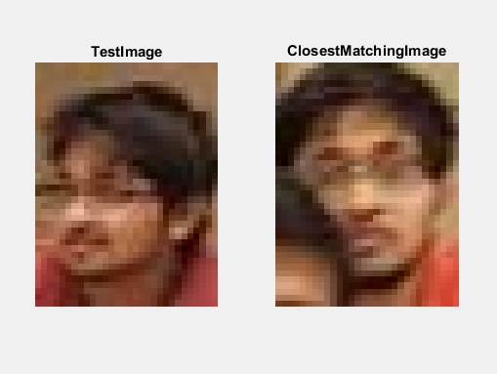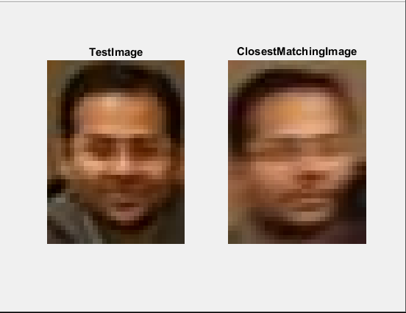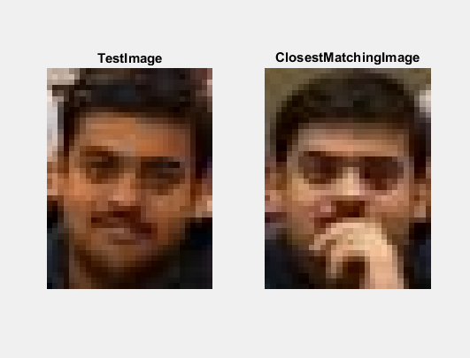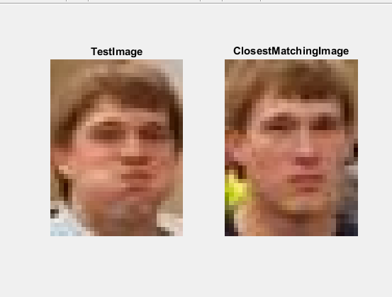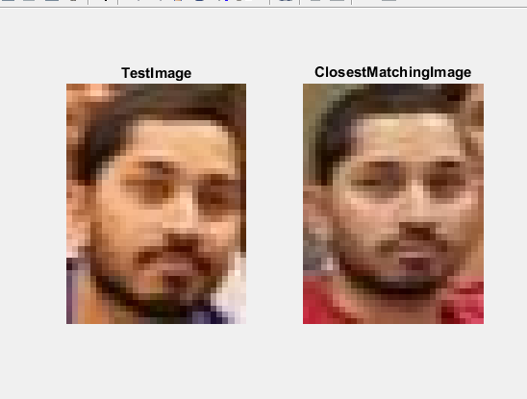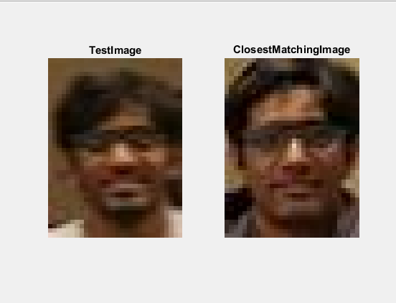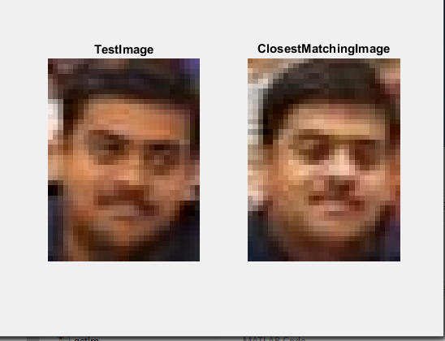

**Observations:**

As the value of K changes the accuracy varies, at certain time it goes to a peak value then again minimizes sometime and later it almost becomes a constant value (i.e it saturates ). The maximum value of k can go up to the total number of training images.

Note:

1. Change the k Values in the code for different accuracies
2. For Norm 1 and Norm 2 there is just a slight difference in the code so read comment in the testing phase and then use the required norm.